ssh-keygen -t ecdsa

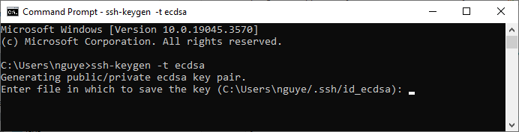

C:\Users\nguye\.ssh

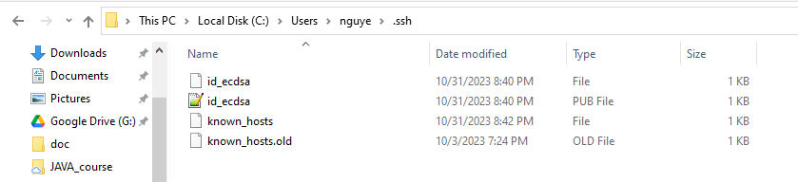

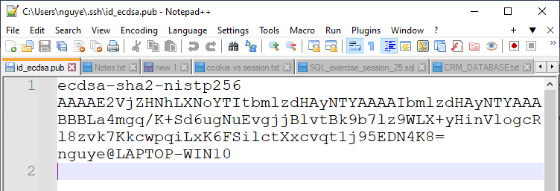

git push -u origin master

>> origin: nghĩa là upload source code lên remote repository, master branch

git push -u origin

git push –set-upstream origin main: khi trên remote repository chưa có main branch

